**Connecting to ec2 via putty**

Step: 1

Download putty [Download PuTTY - a free SSH and telnet client for Windows](https://www.putty.org/) from this website

Step 2 :

Now open puttygenny and click on load and select the file which download

Now click on save private key and specify the folder location

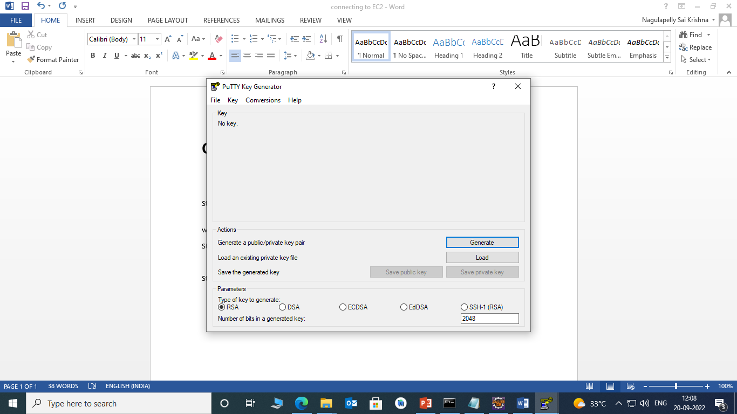

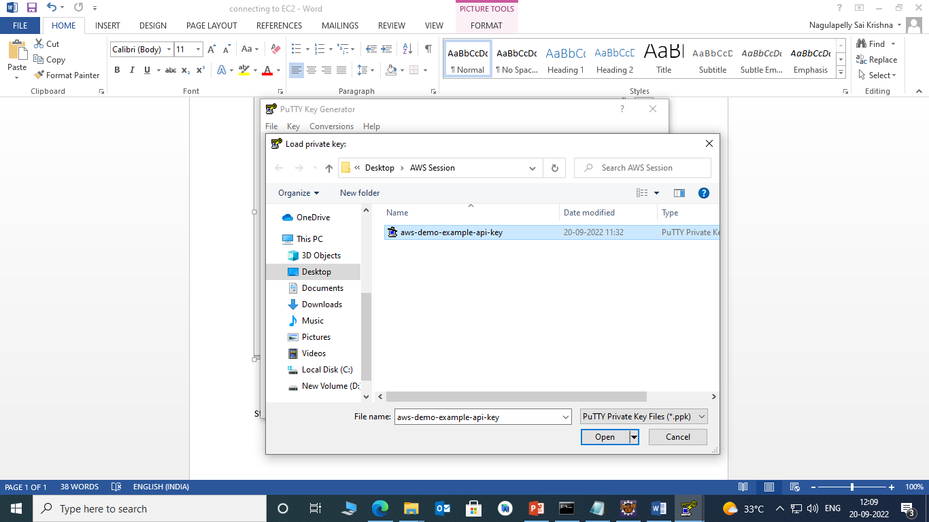

Step 3 :

Now open putty and give host name which will available on ec2 instance

Like “ec2-13-126-225-127.ap-south-1.compute.amazonaws.com” and give user name “ec2@user”